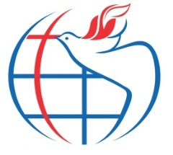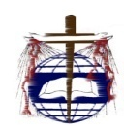**TRUTH EVANGELISTIC FOUNTAIN MINISTRIES INC.**

**TRUTH FOUNTAIN CATHEDRAL - LIRA**

Plot 1-3 Imat Maliam Road, Plot 126 Aloi Road, P.o. Box 382, Central Division, Lira Municipality, Lira District, Uganda. Facebook: [truthevangelisticministriesinc.](mailto:truthministries2017@gmail.com) Website: www.mwa-tef-missions.org Email:

**(page)** **Home**

**large image of inside of current church (alter)**

Worship Times: Sundays at 7AM and 10AM

Youth Service: Wednesdays 5:00pm – 6:30pm

Midweek service: Thursdays 5:00pm – 7:00pm

**Address:** Plot 1-3 Imat Maliam Road, Plot 126 Aloi Road, P.o. Box 382, Lira city East, Lira City.

Email:

Facebook: [truth evangelistic fountain ministries inc.](mailto:truthministries2017@gmail.com)

Website: [www.truthevangelisticfountain.org](http://www.truthevangelisticfountain.org)

**(page) About**

Truth Evangelistic Fountain Ministries (TEFM) was founded on February 25, 2002 and registered with the NGO National Board on August 23, 2002. After our precious Lord laid a great burden for Revival and Evangelism in the heart of Rev Dr. James Okalo Ekwang, TEFM has served and ministered to countless lives in Uganda and across the globe for nearly two decades. Our mission is…

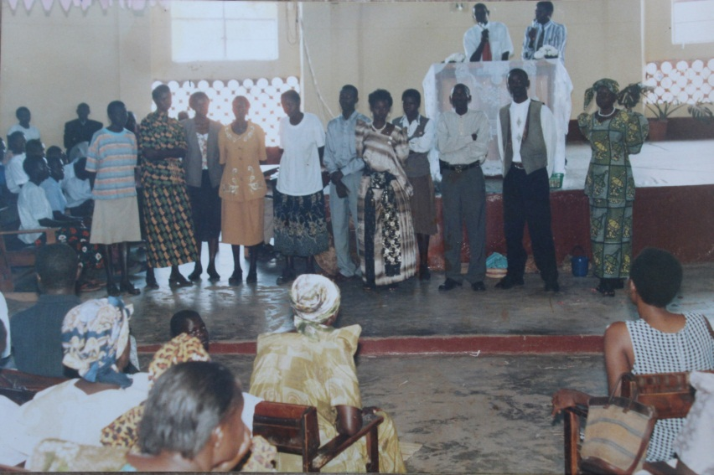

***Evangelists that were present at the onset of the Ministry with Pastor James (3rd right), when Lira Pentecostal Church officially released them for ministry (2002).***

Truth Evangelistic Fountain Ministries is led by Rev James Okalo Ekwang, or Rev James as he is known to his congregation and local community. Rev James…

(Continue your bio here)

Rev Dr James (Dmin, Lead Impact University, MAGL; Fuller Theological Seminary, B.A. Edu; Makerere University, Kampala, Uganda) is the founder and Senior Pastor of Truth Evangelistic Fountain Cathedral Lira with 40 church branches. He host international revival conferences and mass gospel healing crusades. James founded the Uganda version of Children of the Nations, a subsidiary of children of the nation’s international, serving as its country director from 2007 to date, raising orphaned and destitute children with holistic ministry. He is married to Rev Agnes, Blessed with 4 biological; Kimberly Esme Epila, Clark Rabbi Eyul, Bonnke Michael Eden and Kira Eloi Atim and 8 other adopted children.

A man with a very individual walk with God, Rev Dr James experienced many visitations, seen visions and heard at the directives of his savior. Alongside miracles, wonders and the anointing entrusted to him, he has led an untold number of individuals to a walk with Jesus. He and his team have a vision for Uganda that is far reaching. This is their story. Uganda suffered over twenty years of war leaving devastation all over and especially in the northern parts. His story is a riveting accounts of the healing power of God in behalf of the Ugandan people.

Recently Rev Dr James was given a dream and mandate to reach out to his people, the lango of Northern Uganda. Out of this message from God he and Truth Evangelistic Fountain team have birthed lango Evangelization Agenda.

- Include current, clear picture of you with your wife

- Include an image of you and your ministerial team

Today the ministry has branches in many Parts of Uganda, notably Apac , Oyam, Kole, Gulu, Arua, Mbale and Kampala among others. Truth Fountain Cathedral in Lira stands strategically 2KMs away from the Lira town center, off the Aloi Road, by the Lira Airport and the Army barracks:

. 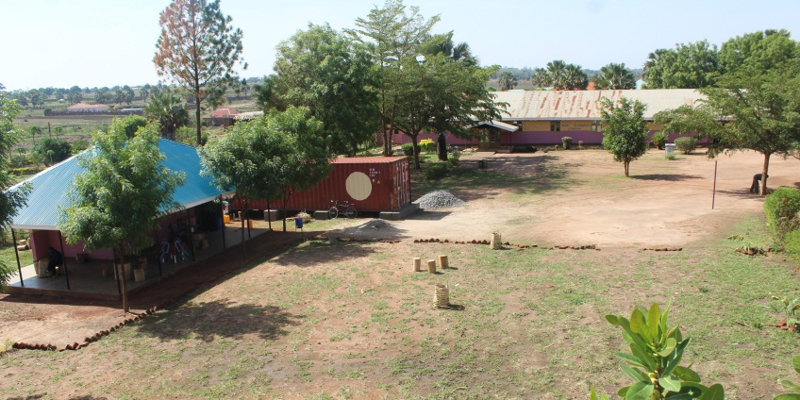

**Expansion Efforts**

Truth Fountain Cathedral is beginning to buid a 5,000 seat capacity cathedral that will be the centre for mission coordination around the world. Below is an artistic impression of the cathedral, as well as our ground breaking ceremony on March 12, 2017:

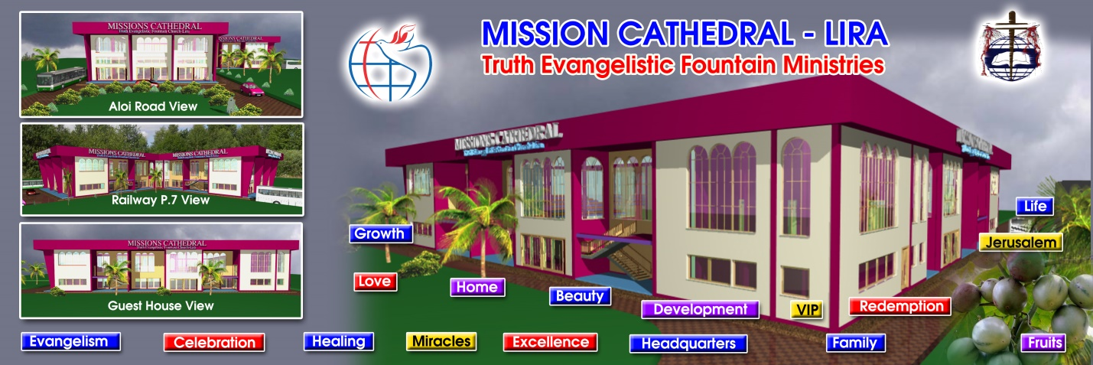

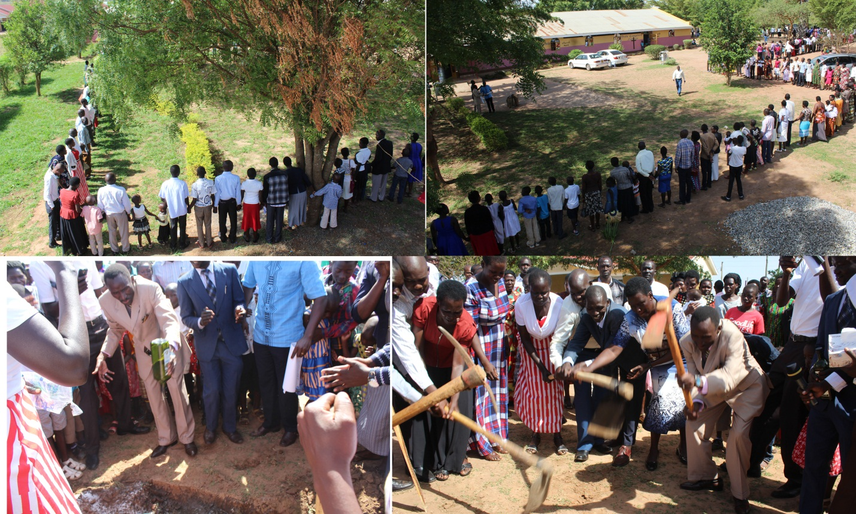

The church is also buliding a guest house 100m away from the Cathedral: 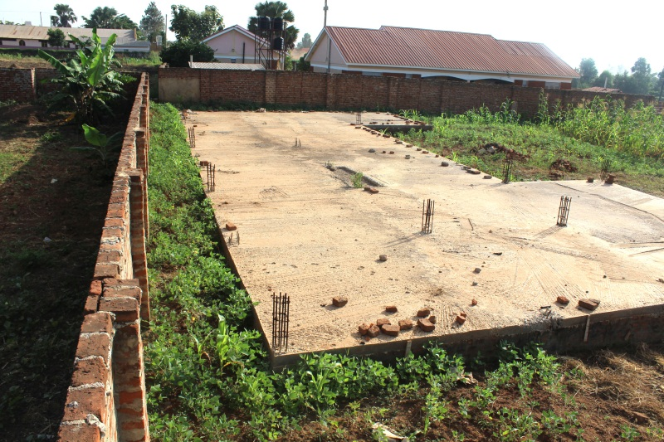

**(Page) Our Ministries**

Truth Evangelistic Fountain Ministries has established multiple ministries and collaborative projects within Lira and surrounding communities. Our programs directly support Orphans and school aged children, vulnerable Women, Homeless, and the Disabled, sick, poor and destitute. Our ministries include:

**CHILDREN OF THE NATIONS UGANDA (COTN, Orphanage and Care for Destitute Children)**

Founded in 2006, this ministry was a response to the 3 decades of rebel mayhem in Northern Uganda that resulted in countless orphans and destitute children left without shelter, food, healthcare, and education. To date, 723 children are directly supported at this program.

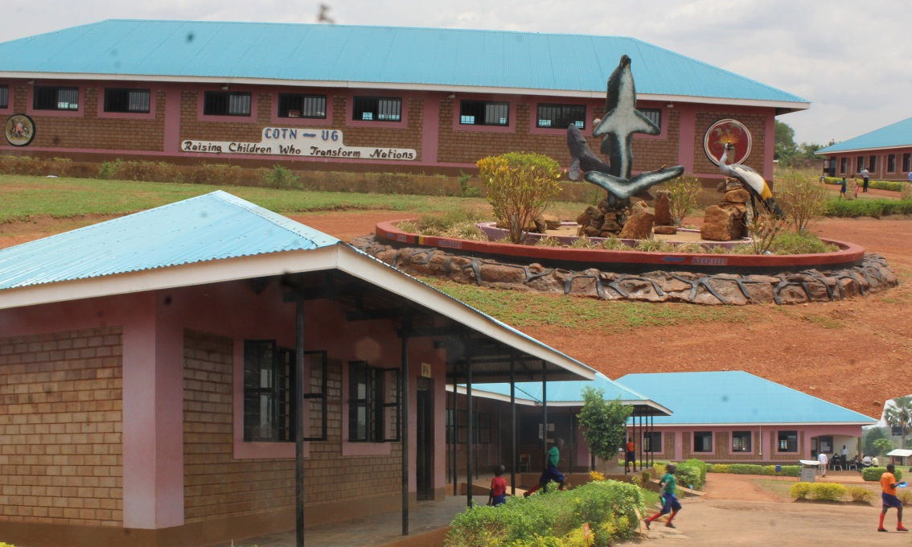

***COTN Uganda campus***

**SAVING GRACE NURSERY AND PRIMARY SCHOOL (For Street Kids)**

Prior to this program, Street kids in Lira had never had a program dedicated to serving their needs. In 2009, a partnership trust was created that began this program, now helping about 200 children access free shelter, medicine and education.

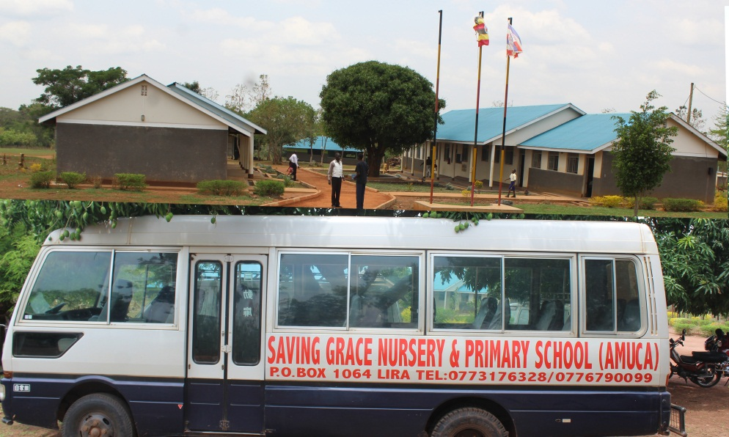

***Saving Grace Uganda***

**TRUTH VOCATIONAL AND TECHNICAL INSITUTE (For school drop outs)**

In 2013, we started a skills training institute that would assist students that had dropped out of secondary (high) school for lack of school fees and other causes. Here, we offer courses such as Block laying (building), Carpentry, Tailoring and garment cutting, Mechanics and driving, Beauty and hair dressing, and Hotel Management/catering:

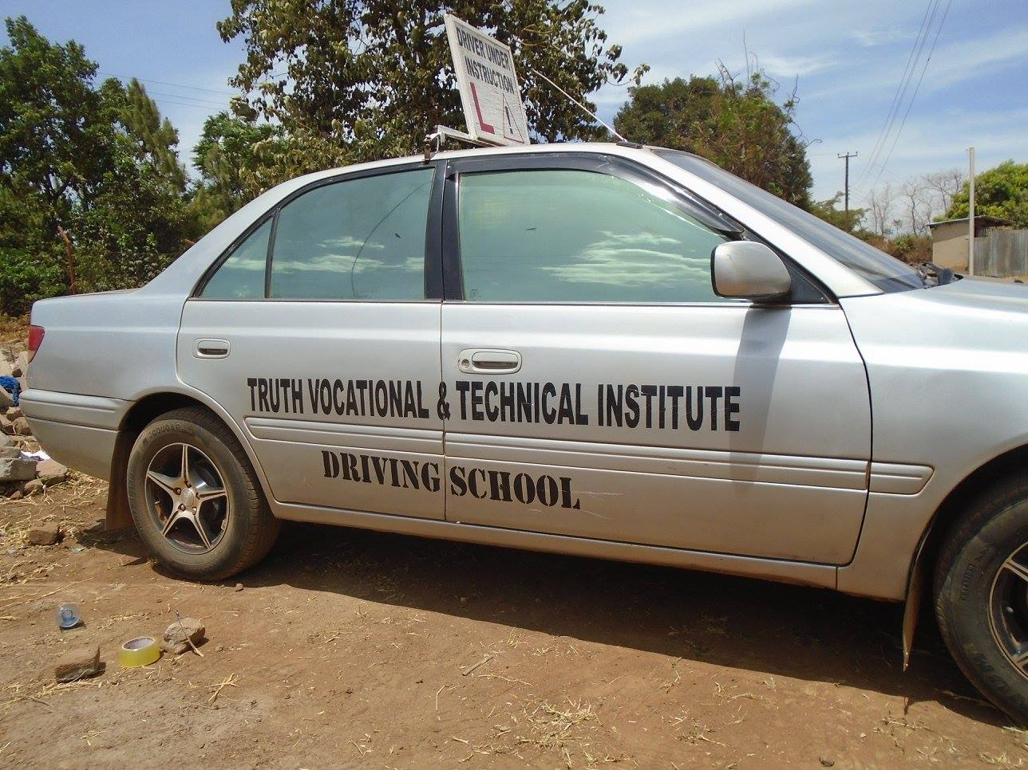

Other humanitarian support programs we do in our ministry include:

**Crown of Glory Ministry**

Distributes packaged meals, hygiene packs to the poorest and most vulnerable people of the communities we serve such as lepers, the aging, and disabled.

.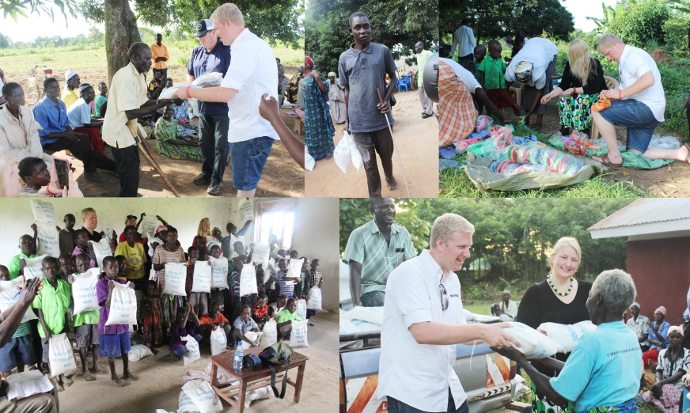

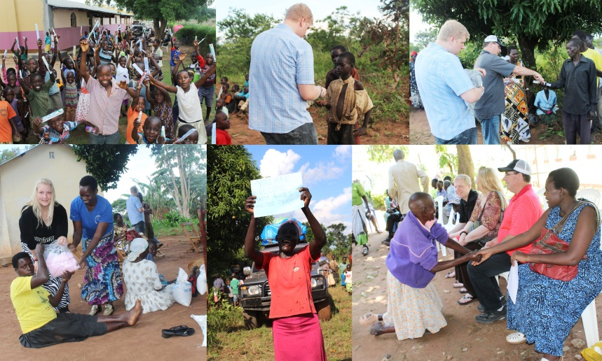

*Crown of Glory ministry giving mama kit, toothbrushes, sanitary pads and medications to the poor*

Wheel Chair distribution to the disabled.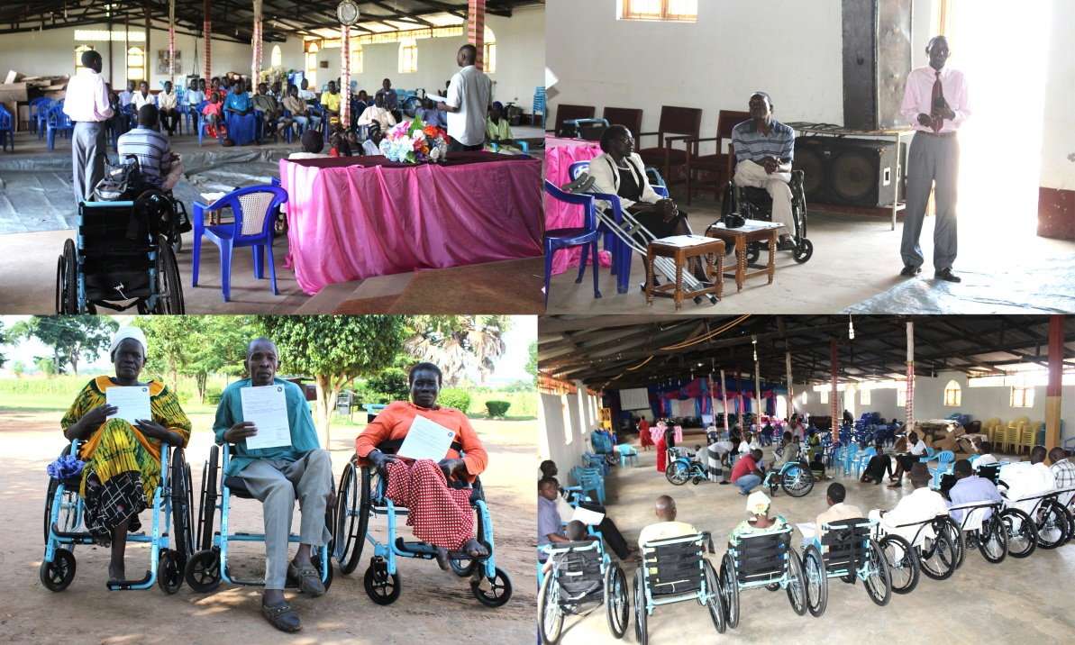

*Rev James speaking to the disable during wheel Chair distribution at Truth Evangelistic Fountain Church*

**Truth Fountain My Sister’s Keeper (MSK) Project**

**Mission: Minister to former sex workers and support women’s empowerment to reduce sexual exploitation and poverty**

My Sister’s Keeper program is a counseling and skills training program aimed at reducing sexual exploitation and poverty on the streets of Lira by educating, empowering and supporting women sex workers in healing and pursuing new careers. This ministry aims to help these women develop sustainable businesses and livelihoods instead of selling themselves for survival. The project, located within Lira town is aimed primarily to reach out to identify, rehabilitate and empower the victims of sexual exploitation or former commercial sex workers and child mothers within the various locations in the surrounding area from where they are. They are taken through psychosocial therapy, introduced to Christ and brought to the Church, and empowered and trained in livelihood skills like catering, tailoring, etc. to make them self reliant after their successful completion of the rehabilitation process. This is intended to provide opportunities for those women to discover and build skills by engaging in other money generating activities than the commercial sex business. Some of the women may not pursue a business, but reunited with their families and return home. The success of this program involves participation of church influencers/ teachers and partnerships with the local community and other partners who can support in various ways.

**Achievements:**

* Our program has helped 50 sex workers
* A good number of them who could read were provided Bibles
* All who received training and skill development didn’t return back to the streets to commercial sex work
* Many have been reunited back to their families in the village
* Some are still reliant on the church to support their start up projects
* Some have remained permanent members in the church
* One is now serving in the church as the church usher
* Others voluntarily enrolled as church intercessors

**Continued Outreach Efforts:**

* Child mothers or teen pregnancies
* Sex workers
* Community education on the dangers of early pregnancies

*My Sister’s Keeper leader and other church influencers from their training*

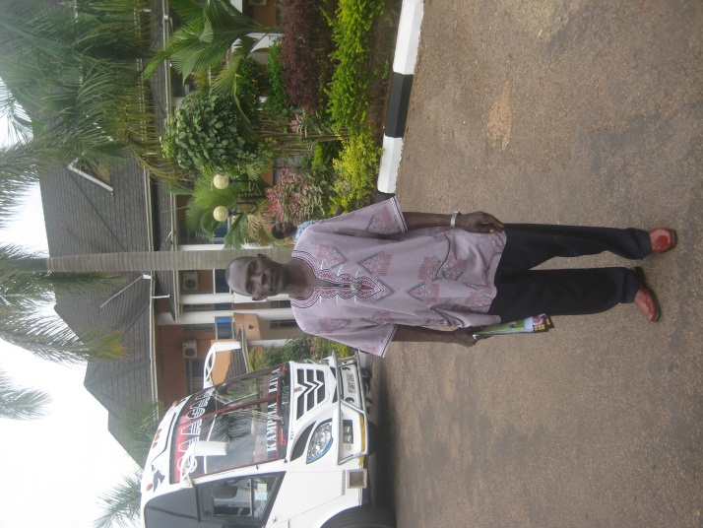 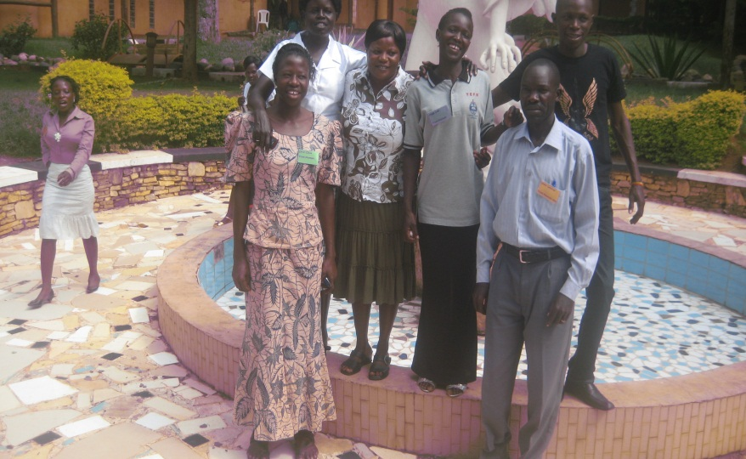

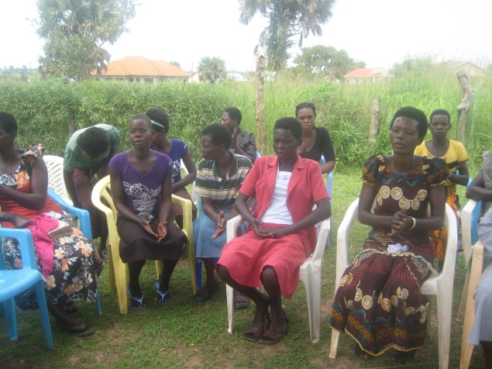 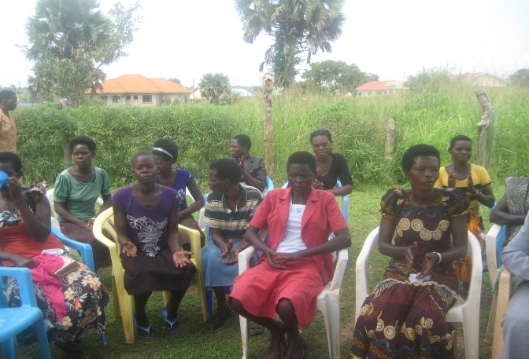

*Women that have completed MSK program*

**(Page) Conferences & Evangelism**

Truth Evangelistic Fountain Ministry holds an annual mega conference that draws people from across East Africa and other countries. The High Voltage Miracle Conference has been held for the last 15 years and has recorded more than 20,000 people in attendance each year. Rev. James has led crusades and Pastors conferences in many districts of Uganda.

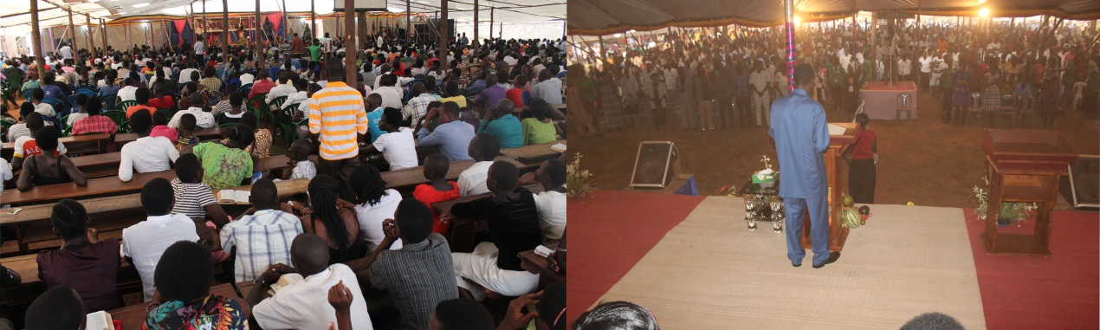

*The 15th International High Voltage Miracle Conference*

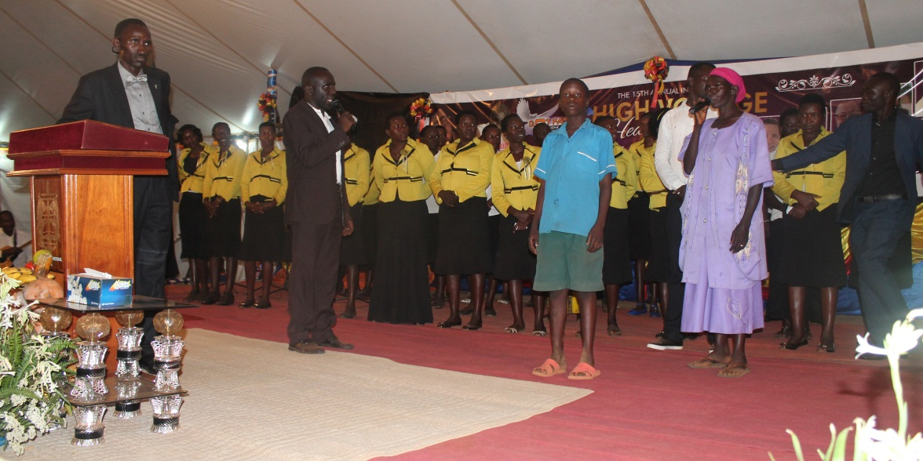

*Rev. James praying over the sick at the 15th annual international High Voltage Miracle Conference*

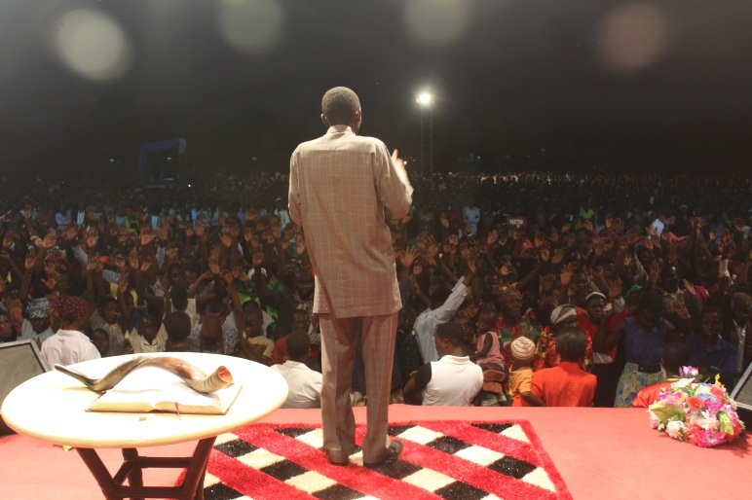

Rev James leading people to Christ in Soroti Miracle Crusade

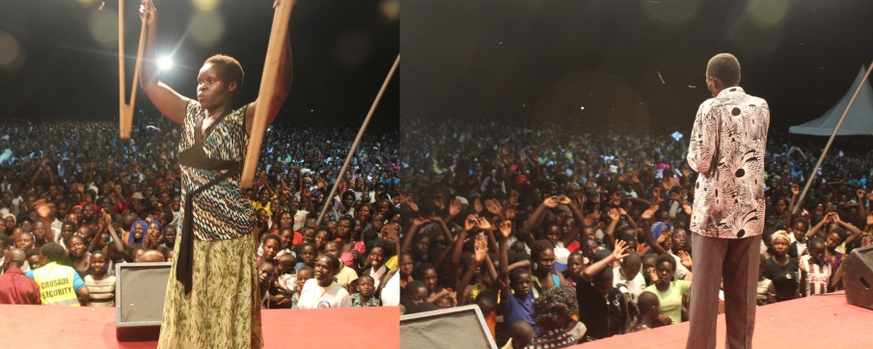

*Rev James in Gulu Miracle Crusade­*

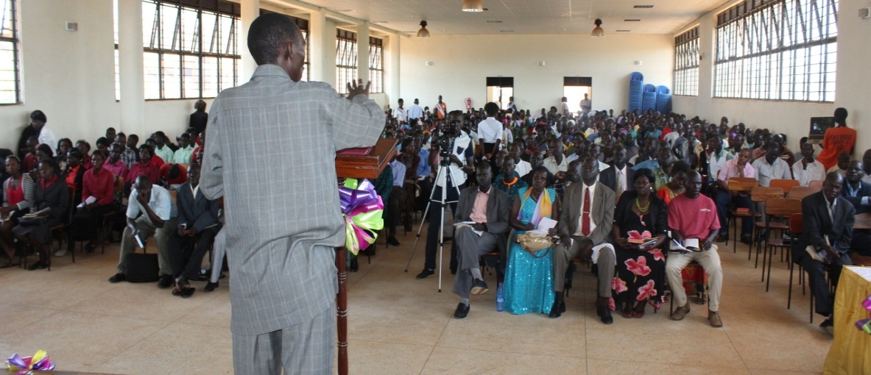

*Rev James Speaking to Pastors during Gulu Miracle Crusade*

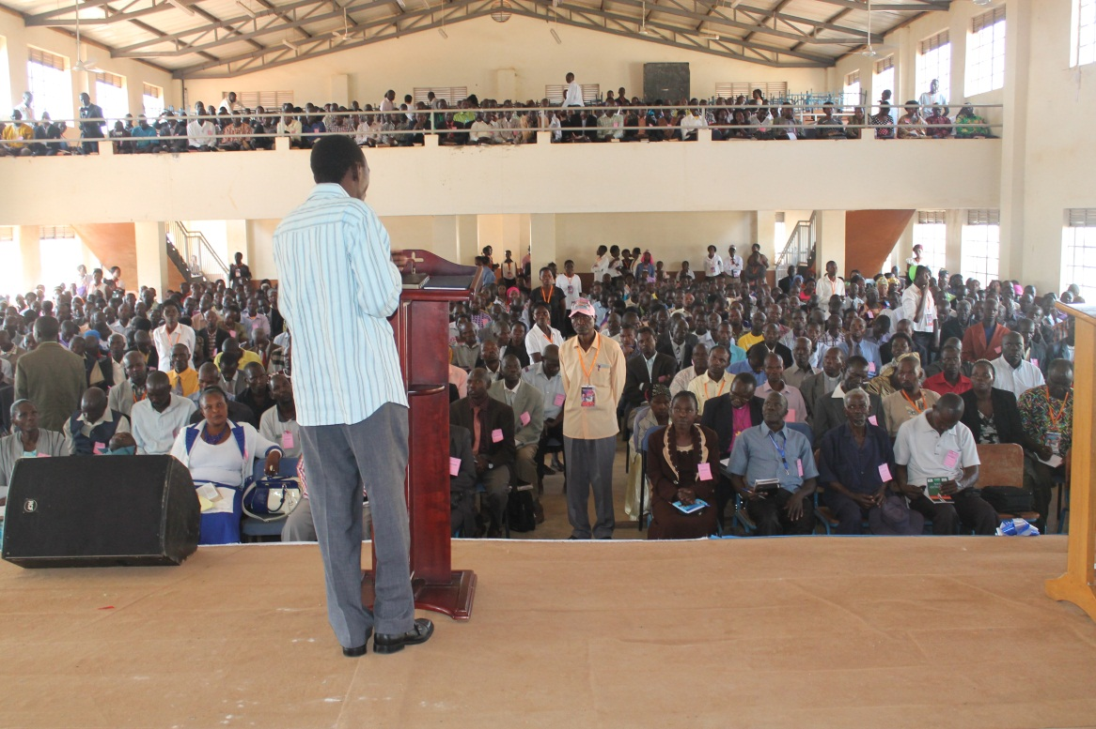

*Rev James Speaking to Pastors in Mbale during Mbale Miracle Crusade*

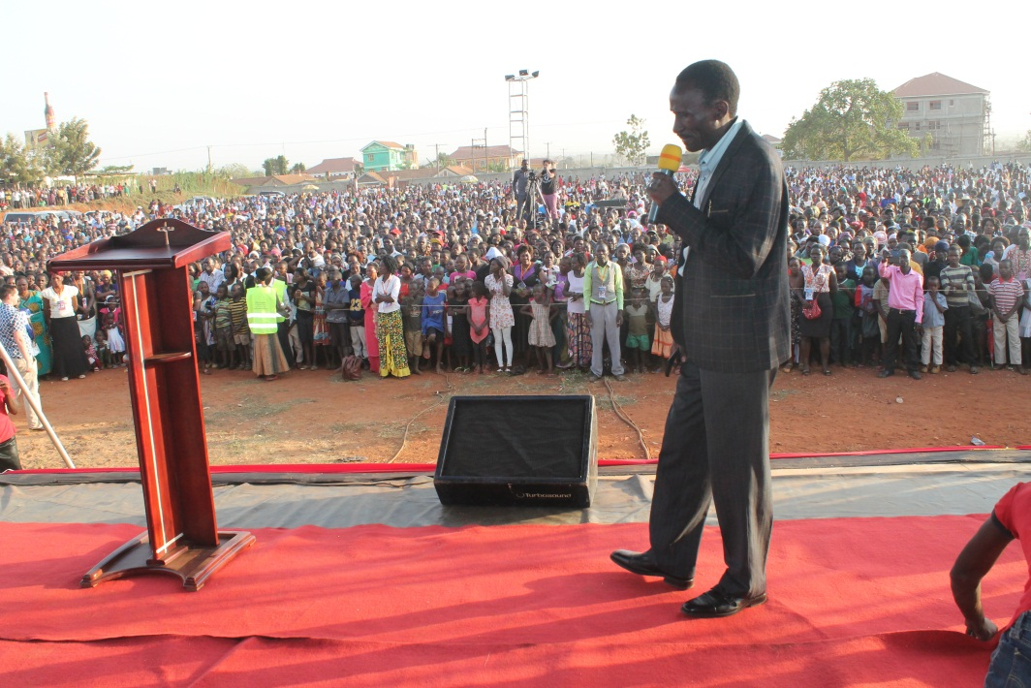

*Rev James Preaching in Mbale Miracle Crusade*

**(page) Get Involved**

Truth Evangelistic Fountain Ministries is expanding in size and scope in order to spread the Good News of the Gospel and address the very real, complex challenges facing the vulnerable communities it serves in Northern Uganda and beyond. We cannot do this alone. Below are current and future soul and community winning programs that we would appreciate having your church or organization prayerfully consider getting involved with:

* Support **Church expansion** efforts, outreach programs and **Ministries** (hyperlink to Ministries page)
* Build a Mission Hospital to offer free and subsidized healthcare to the local community
* Build a Mission Hotel for sustainability

If your organization would like partner with our church in evangelist efforts and programs through volunteering and/or fundraising, please be in touch with Rev. James at (email). We also partner with **Uganda Drive Tours and Travel (hyperlink)** to help coordinate your group’s travel and stay to Uganda. Thank you.